BENEFITING
COCHUSA

YOUTH

The Kerry J. Allen Scholarship Board is an entity of the National Sunday School and Holiness Youth Ministries of the Church of Christ Holiness, USA, and was established to provide financial assistance to COCHUSA youth who are pursuing a college education.

Each year the money made from the Golf Classic adds to the funds earmarked by the KJA Scholarship Board to award scholarships to deserving students across the United States, who are members of the Church of Christ Holiness USA. To date, the KJA Scholarship Board has awarded over $140,000 in scholarships and it is our hope that this golf classic will help in raising more funds. The scholarships are given annually and are renewable. Your support helps the students to purchase books, supplies, or even pay tuition.

Enclosed are the Golf Classic Registration Form and the Sponsorship and Donation Form. All donations are tax deductible.

For further information please contact:
William Sherman
P.O. Box 1863
Conway, AR 72033
(501) 327-2120
Email: wmsherman@conwaycorp.net

*Special thanks to our sponsors:
Samuel Bingham Insurance Agency - Los Angeles, CA
Merchant Services (Chris Perkins) – Jackson, MS
Richard Wilson – Bradbury, California

www.kjascholarship.com

COCHUSA CONGRESS
KJA SCHOLARSHIP BOARD
c/o William Sherman
P.O. Box 1863
Conway, AR 72033

Kerry J. Allen
COCHUSA Scholarship Board

ANNUAL

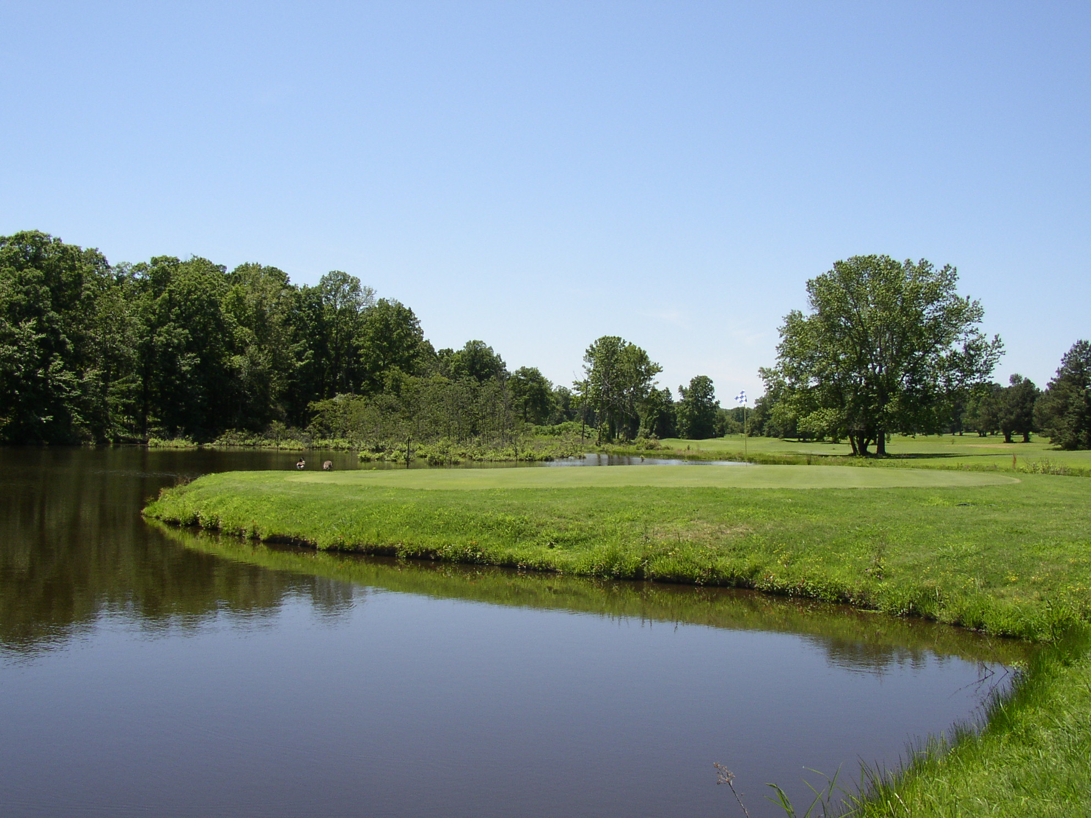
CLASSIC
2012

Saturday, May 12, 2012

Sponsored By:
Samuel Bingham Insurance Agency
Merchant Services, Chris Perkins – Owner
And
Richard Wilson
CHURCH OF CHRIST (HOLINESS) U.S.A.
NATIONAL CONGRESS SCHOLARSHIP
GOLF CLASSIC

DATE: MAY 12, 2012

LOCATION: COUNTRY CLUB OF ARKANSAS
#3 Country Club Drive
Maumelle, AR 72113
(501) 851-0095

TIME: REGISTRATION - 7:30 A.M

TEE TIMES - 8:00 A.M.

TYPE: FOUR-MAN SCRAMBLE

FEES: $80.00 PER PLAYER
Register by May 4, 2012
(FEES INCLUDE GREEN
FEES, CART & LUNCH)

PRIZES: FIRST & SECOND PLACE
INDIVIDUAL TROPHIES

LONGEST BALL AND
CLOSEST TO THE HOLE
PRIZES

DONATION: $10.00 PER SPECTATOR
(includes lunch)

FOR MORE INFORMATION CONTACT:

WILLIAM SHERMAN
OFFICE: (501) 327-2120

EMAIL:
wmsherman@conwaycorp.net
Fax: (501) 327-3270

SPONSORSHIP AND DONATION FORM

Name of Sponsor/Donor
Address

Telephone Number
E-mail Address
Contact Person

Type of Sponsorship

Platinum -- Hole Sponsorship $100.00*

Gold Sponsorship $ 75.00

Silver Sponsorship $ 50.00

Bronze Sponsorship $ 25.00

Spectator Club Donation $ 10.00

*A sign will be placed at the Hole identifying the sponsor(s) name(s). Please indicate the name to be put on the sign:

Sponsorships and Donations are Tax Deductible

Sponsorship Deadline: May 4, 2012

Please make checks payable to:

KJA Scholarship Fund
Mail To:
WILLIAM SHERMAN
P.O. Box 1863
Conway, AR 72033

PLAYER & TEAM ENTRY FORM

NAME:
PHONE#:
ADDRESS:
CITY, STATE
ZIP: EMAIL:

NAME:
PHONE#:
ADDRESS:
CITY, STATE
ZIP: EMAIL:

NAME:
PHONE#:
ADDRESS:
CITY, STATE
ZIP: EMAIL:

NAME:
PHONE#:
ADDRESS:
CITY, STATE
ZIP: EMAIL:

Registration Deadline: May 4, 2012

Please make checks payable to:
KJA Scholarship Fund

Mail or Fax Entry Form To:
WILLIAM SHERMAN
P.O. Box 1863
Conway, AR 72033

